Answer the following questions in brief.

1. Name the four realms of the Earth.
The four realms of Earth are:

a. Lithosphere

b. Hydrosphere

c. Atmosphere

d. Biosphere.

2. Where is the Great Barrier Reef located?
The Great Barrier Reef is located in Australia.

3. What is the biosphere?
The interaction between the lithosphere or land, hydrosphere or water and atmosphere or air gives origin to the realm or zone of life called the biosphere.

4. What is habitat?
All forms of life, ranging from the tiniest microorganism to the largest plant and animal, are found in the biosphere that becomes their habitat-a natural environment where life thrives and multiplies.

5. What is global warming? How is it caused?
The high level of emission of greenhouse gases, such as carbon dioxide, methane and nitrous oxide, emitted from industries and vehicles, trap the Sun's heat in the atmosphere and do not allow it to escape. This heat is then re-emitted in all directions. This is called the greenhouse effect. The increase in greenhouse gases in the atmosphere causes an increase in the Earth's atmospheric temperatures causing the phenomenon of global warming.

Answer the following questions in detail.

1. Discuss the main components of the lithosphere with the help of a diagram.
The main components of the Lithosphere are

a.CRUST: The uppermost solid layer of the Earth's surface is known as the crust. It is
made up of two solid layers Sial (upper crust) and sima (lower crust). Sial gets its name from silicon (Si) and aluminium (Al) as it has rocks that are rich in both these minerals. Sima gets its name from silicon (Si) and magnesium (Mg) present in good quantity in the rocks of this layer.
b. MANTLE: The mantle lies below the crust, and it is made up of rocks that are denser than the crust. The uppermost part of the mantle is made up of solid rock. It is made of rocks that are in a semi-solid state. This is due to extreme heat and pressure. The mantle is up to a depth of 2,900 km.
c. CORE: Below the mantle is the core of the Earth. The core is made of heavy metals such as iron and nickel. While the inner core is solid, the outer core is semi-solid because of the pressure and heat generated here.
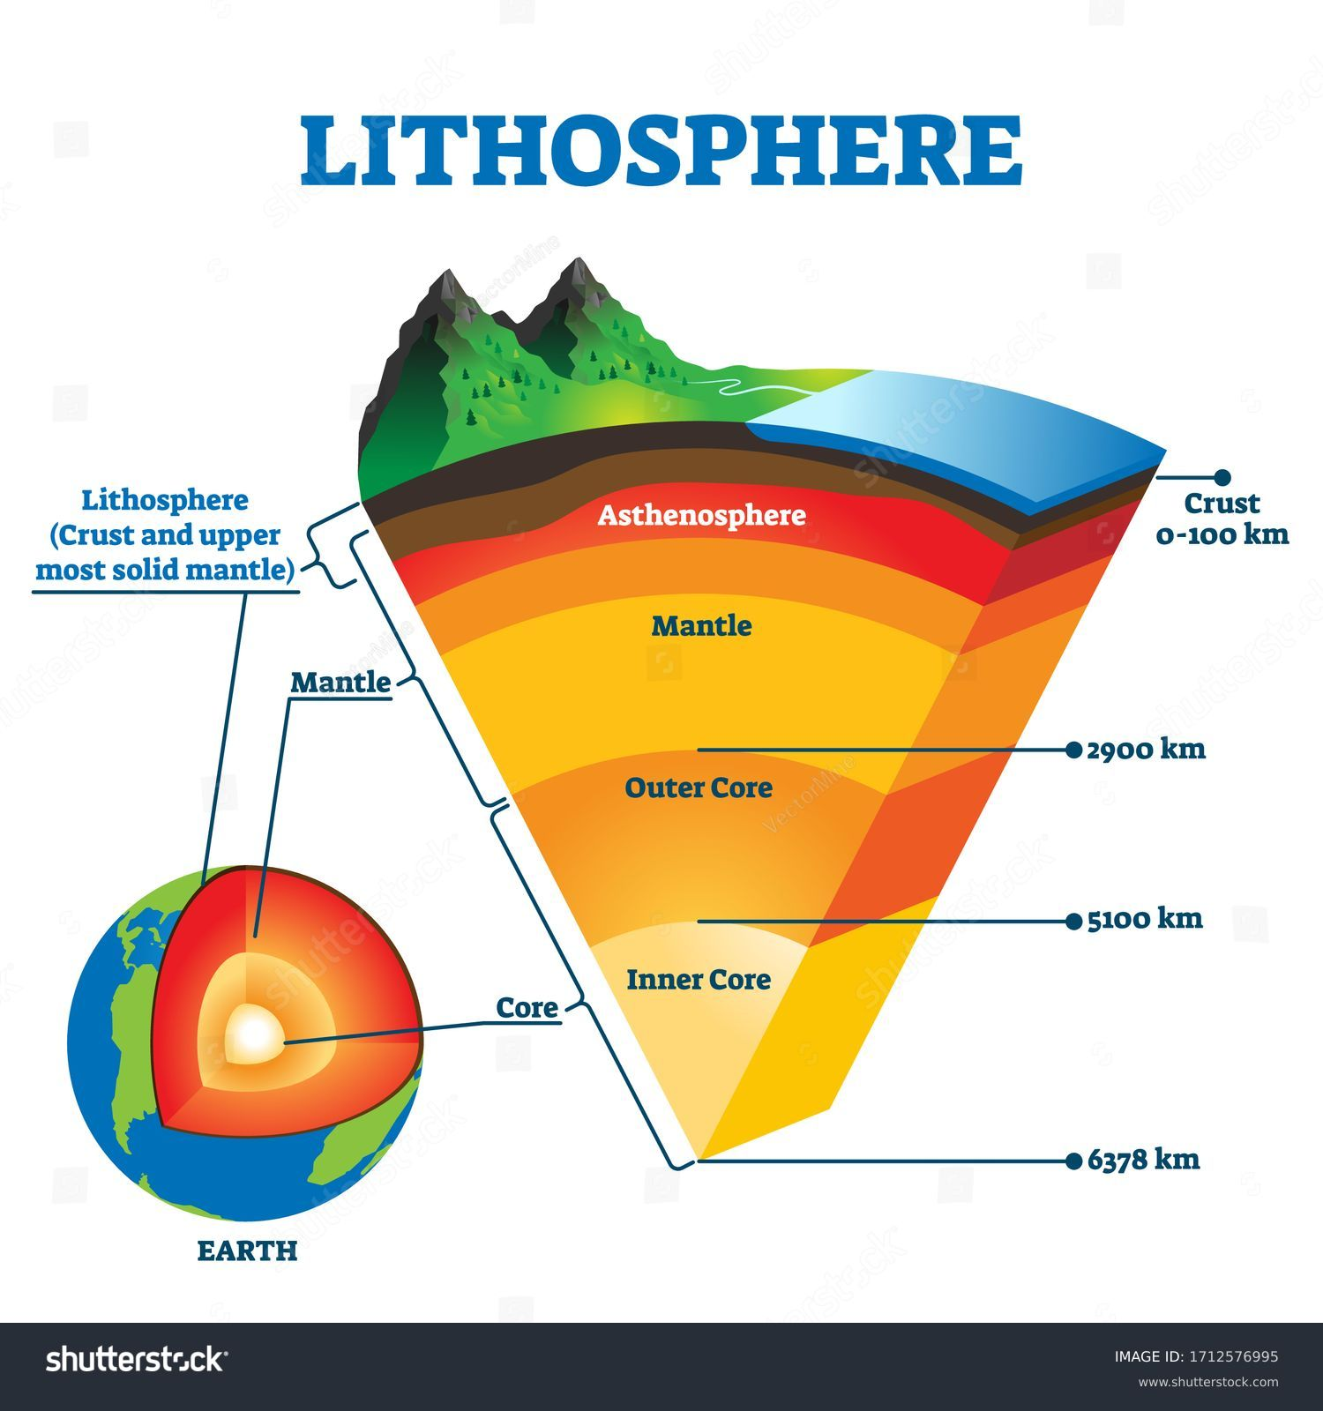

2. Mention the ways in which the hydrosphere is important to life.
a.Human needs like domestic, commercial, generation of hydroelectricity

b. It acts like a habitat of large number of aquatic animals.

c. It regulates temperature of coastal areas.

d. It links all the landmasses.

e. It provides us with various minerals (salt) and precious pearls.

3. Explain the hydrological cycle.
Water keeps changing from one form to another in a cyclical manner within the hydrosphere. The endless series of changes undergone by water in the hydrosphere between the sea, air and land is known as the hydrological cycle or the water cycle
a. Water from oceans, seas and rivers, on heating becomes water vapour and rises the air through evaporation.
b. The water vapour then cools and changes into minute water droplets through condensation.
c. These tiny droplets of water join together to form clouds. On cooling further, the tiny droplets in clouds become larger and fall as rain. This is known as precipitation.
d. Precipitation happens also in the form of snow or hail. Precipitation helps to maintain supply of freshwater on the Earth.
e. This rainfall/snowfall feeds glaciers, rivers, lakes and underground water sources, and eventually goes back to the oceans, thus completing the water cycle.
4. What is the atmosphere? Describe different layers of the atmosphere.
The realm of air that surrounds the Earth is called the atmosphere.

The atmosphere can be divided into layers:

a. The troposphere is the lowest layer and also the most related to life on Earth. The troposphere extends upwards for about 8 km to 16 km. Most weather phenomena are noticed here.

b. Extending to about 50 km above the troposphere, the stratosphere is important because of the ozone layer. This layer protects us from the lethal ultraviolet rays of the Sun.

c. The mesosphere, which extends above the stratosphere, is where many meteors get burnt as they enter the Earth's atmosphere. This stretches to about 85 km.

d. The thermosphere that also includes the ionosphere, overlaps the mesosphere and continues to about 640 km. The ionosphere is important as its electrified molecules or ions make radio and television wave transmission possible. All satellites are, therefore, stationed in this layer.

e. Beyond the thermosphere/ionosphere is the exosphere, which is made up of extremely rarefied air. It extends to about 10.000 km. Space stations are located at its lower margins: The exosphere merges with outer space.

5. Discuss the importance of ecological balance in nature.
Importance of ecological balance in nature:

a. This balance ensures survival, existence and stability of the environment.

b. Survival of all organisms is actually possible because of this balance only.

c. They get enough food to eat to maintain their survival.

d. It ensures a stable environment that is free from floods and droughts.

e. It provides a conducive environment where all organisms can survive.

